**SPRING REST**

**Webservices**: Integration of multiple application which are design using same or different technology and which are running on same or different server.

**Types of webservices:**

1. SOAP Webservice
2. Restful Webservice

**Need of webservice**

* It provides common communication language when multiple applications are communicating with each other.
* It generally uses XML or JSON language

**REST**

REST stands for **Re**presentational **S**tate **T**ransfer.

It transfers state(data) in global format(representational) between two different applications running on different servers Data might be primitive or non primitive like object, array, collection, etc

* In restful webservice, all application use JSON language for data transfer

In restful webservice, we generally have two type od applications,

1. Consumer application : an application who requests data is called as consumer application
2. Provider application: an application which provides the data based on request is called as provider application

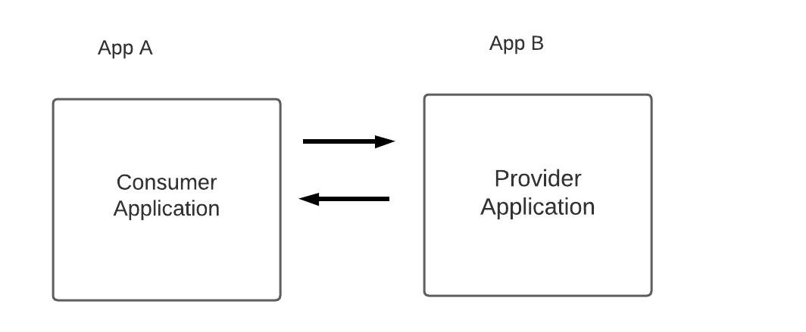

We use JSON language to communicate with different application. In java, we have **ObjectMapper** class which will convert java language to JSON lang.

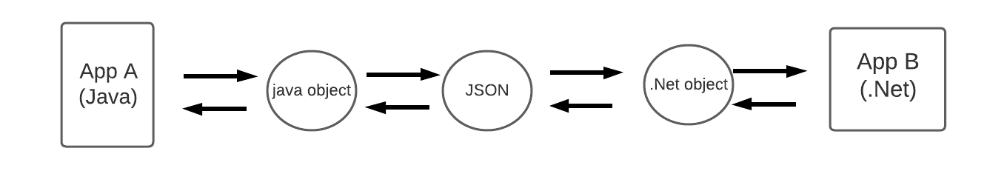

When multiple application communicate with each other, first their respected objects will get convert into JSON and vice versa.

Copy paste object mapper ex here:

In restful services, we send request and get response from different application. For that we use some annotation. So, in order to send request, we can use POSTMAN as client tool/consumer application.

**Types of request:**

1. Get request : we can send only primitive data
2. Post Request : we can send non primitive data
3. Put Request: we can send non primitive data
4. Patch request; : we can send non primitive data
5. Delete Request : : we can send primitive data

**PROVIDER APPLICATION CREATION**

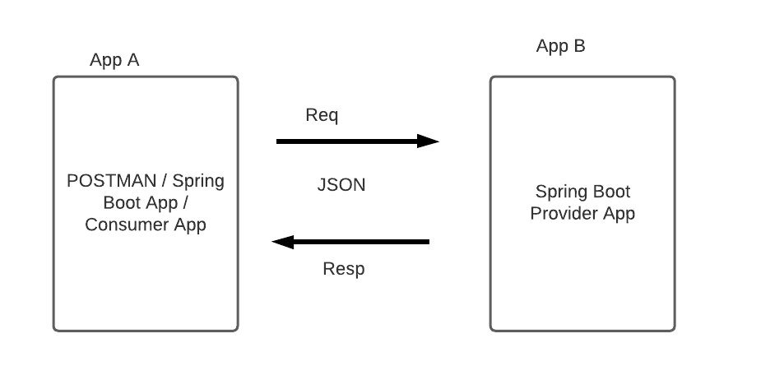

GET Type request

* We can send only **primitive data** with GET type request
* We can send data using URL with the help of ***path parameter or query param.***
* Path param : [http://localhost:9080/getData**/12**](http://localhost:9080/getData/12) **: path param**
* Query Param: [http://localhost:9080/getData**?id=12**](http://localhost:9080/getData?id=12) **: query param**
* In controller, we use **@PathVariable** and **@RequestParam** to read data from GET type request
* We can send GET type request by
  + Hyperlink
  + POSTMAN tool
  + Using browser

**@RestController** : this annotation is used on top of controller class to make normal java class as controller layer class. This class is used for handling the requests coming from consumer applications.

Below example shows how to fetch GET type request and fetch data from it.

package com.nt.SpringRest_ProviderApp;  
  
import org.springframework.web.bind.annotation.PathVariable;  
import org.springframework.web.bind.annotation.RequestMapping;  
import org.springframework.web.bind.annotation.RequestParam;  
import org.springframework.web.bind.annotation.RestController;  
  
@RestController  
public class MyController {  
  
 *//: http://localhost:9080/getName* @RequestMapping("/getName")  
 public String getName() {  
 System.*out*.println("getTypeRequestMethod() executed");  
 return "Nikhil";  
 }  
  
 *//: http://localhost:9080/getSurname* @RequestMapping("/getSurname")  
 public String getSurname() {  
 System.*out*.println("getTypeRequestMethod() executed");  
 return "Deshpande";  
 }  
  
 *//http://localhost:9090/getData/65  
 //@GetMapping("/getData/{id}") // template variable  
 //@RequestMapping(value = "/getData/{id}",method = RequestMethod.GET)* @RequestMapping("/getData/{id}")  
 public String getPathParamDataFromRequest(@PathVariable("id") Integer id) {  
 String message = "Id : " + id;  
 return message;  
 }  
  
 *//http://localhost:9090/getQueryParamData?age=34* @RequestMapping("/getQueryParamData")  
 public String getQueryParamFromRequest(@RequestParam("ageOfMan") Integer age) {  
 String message = "Age : " + age;  
 return message;  
 }  
  
}

**POST type request:**

POST type request is used to send large data like non – primitive data